3.

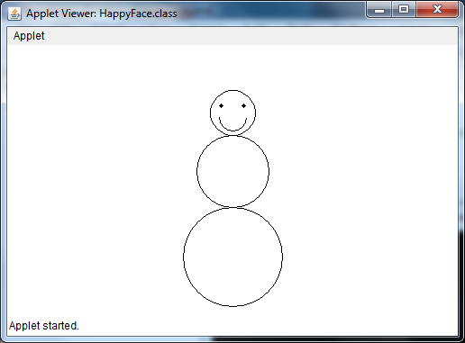

4.

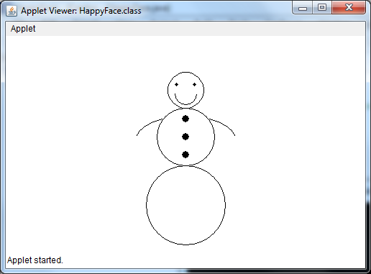

7. #21: If you were to change the order in which you write the drawing commands, it would alter the features one would see. Normally, you would want the largest piece in the background and as the features got smaller, one would add them later. In the case of the question, the mouth, since declared first, would be covered by the face.

#22: In this case, the face is coded twice. In doing so, the original color of the yellow face and the mouth will be covered by the new black face.